Libwebsocks

Conteúdo

libwebsockets 2
Windows vcpkg – installation procedure 2
Prerequisites for installation 2
VCPKG installation 2
GitHub – installation procedure 3
Downloading 3
Pre building 3
Building the library 3
Installing the library built by Visual Studio 4
Making the library available to Visual Studio 5

libwebsockets
Libwebsockets (LWS) is a flexible, lightweight pure C library for implementing modern network protocols easily with a tiny footprint, using a non blocking event loop. It has been developed continuously since 2010 and is used in tens of millions of devices and by thousands of developers around the world.

Windows vcpkg – installation procedure

VCPKG installation
The following command will install libwebsockets and all the necessary packages.
c:\src\vcpkg\vcpkg install libwebsockets:x64-windows

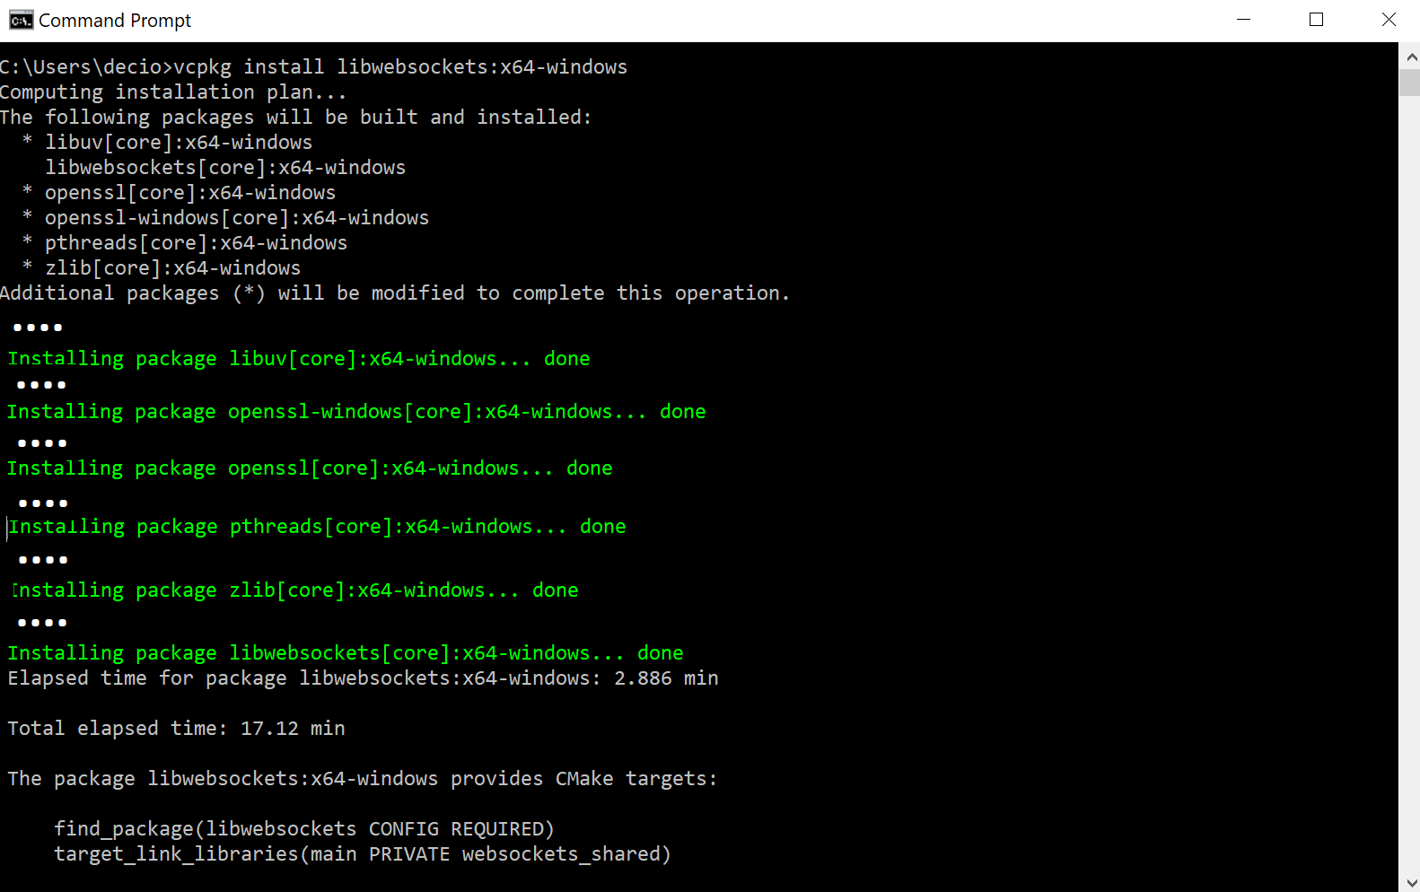
The following packages will be installed by vcpkg:
c:\src\vcpkg\vcpkg list

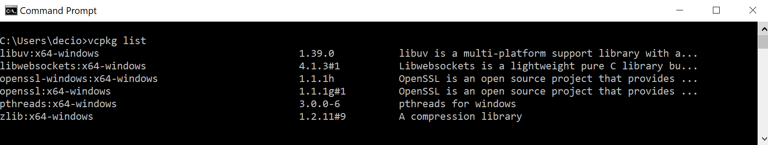

GitHub – installation procedure

Downloading
The latest release should be downloaded from: https://github.com/warmcat/libwebsockets

Pre building
After the download of the “libwebsockets lightweight C networking library source code”, the next step is to build a source code to be compiled by the Visual Studio.
This build process is executed using cmake (*) as detailed here:

mkdir <path_to_the_lib_dir>
cd < path_to_the_lib_dir >
git clone https://github.com/warmcat/libwebsockets.git
cd <path_to_the_lib_dir>\libwebsockets
cmake CMakelists.txt –G “Visual Studio 16” –B “.\build”

Once the cmake finishes processing, it will create a new source code on the following build sub-dir: <path_to_the_lib_dir>\libwebsockets\build

Building the library
The next step is to use the Visual Studio to build the library as detailed next:

- Open the Visual Studio project: ALL_BUILD.vcxproj

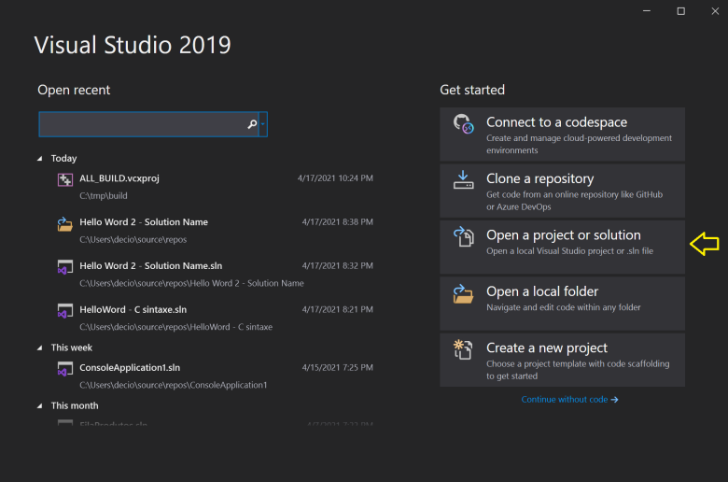

- Select the option Release and then Right-click over the Solution Name (libwebsockets) and select the option: Build Solution

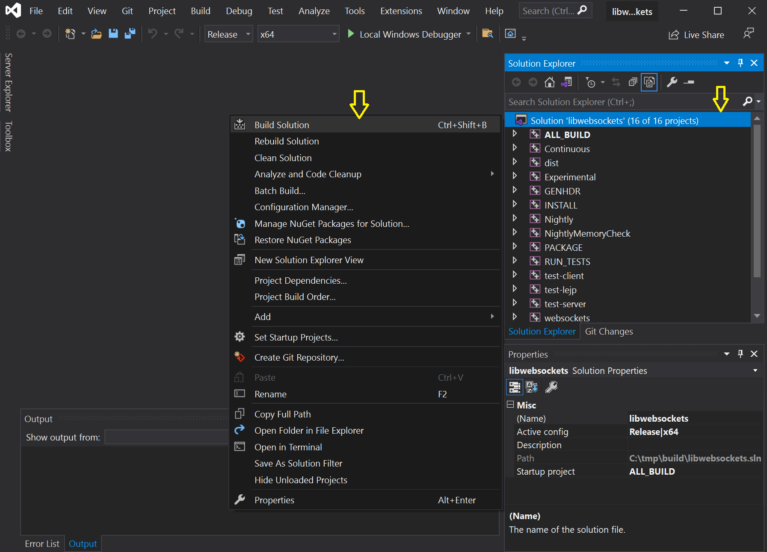

Installing the library built by Visual Studio

After the successful built the following sub-dir will be created inside the libwebsockets directory :

<src files dir>\lib\release\ *.*
<src files dir>\include\*.*

Copy those sub-dir to a folder inside windows to future reference then to compile your projects. Example:

Criar a seguinte pasta: c:\Program Files\libwebsockets
Copiar a DLL para o sub-dir bin da pasta criada anteriormente
<src files dir>\bin\release\*.* → c:\Program Files\libwebsockets\lib
Copiar o conteúdo de todo o sub-dir include para a pasta include
<src files dir>\bin\include\*.* → c:\Program Files\libwebsockets\include

other to future reference those files on Visual Studio :

Making the library available to Visual Studio

